ConsoleHoster Project

ConsoleHoster is an application aimed to easy the work with console-based applications. One of the most important features it provides is that it allows the user to work with multiple console-based applications (projects later on) the same time – opening each in a separate tab within its main window.

## Project

A project is the representation of a console-based application within the application. To create/configure a project, the user need to go the **File > New** menu, and a “New Project” window will appear:

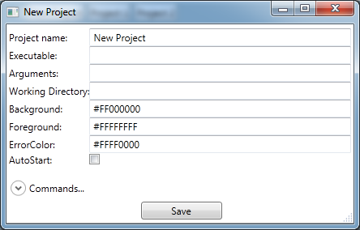

In that window the user need to provide a unique name for the project, specify the executable, arguments to the executable if any, the working directory, background color for the project, foreground color for the messages and error color for the messages coming out through the error stream of the project. There is also a checkbox for the user to check, called AutoStart, which shows whether to start that project as soon as the application will be loaded or not.

As a secondary items in “New Project” window the user can define custom commands for that particular project, by expanding the “Commands…” section on the window. 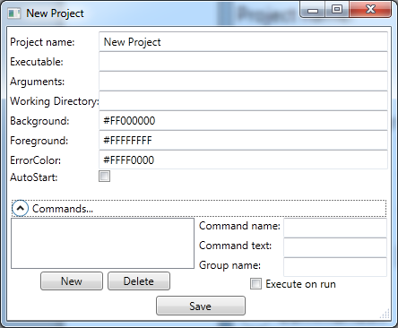

To add a command for the project, user needs to click the “New” button, and a command will appear in the list left, with details showing up on right hand side of the window. For each command the user needs to specify a unique command name, command text, which will be executed or pasted, when the command button will be pressed, and a group name, to group the command in particular group. The checkbox for a command shows whether the command will be executed right away, when the button will be clicked, or the command text will be just pasted in the command typing area of the project window.

### Importing shortcuts

In some cases the users will already have a shortcut for their application with proper parameters. To make life easier “Import project” functionality is available so going to the File > Import menu an open file window will appear, where the user will need to choose the shortcut. As soon as the shortcut will be selected an Ok will be pressed the user will be taken to the Project details window, with all the necessary fields prepopulated from the shortcut.

So the only remaining thing the user may need to modify will be the Project Name field.

### Commands

For each project the user have the ability to specify commands. Commands can be either one line or multiline- in which case each line of a command will run as a separate one, as soon as the previous one will finish.

So for the user can define commands which redirect the user to some folder, and group them into “Favorites” group. Those will appear in the main window for that project as shown in the following picture:

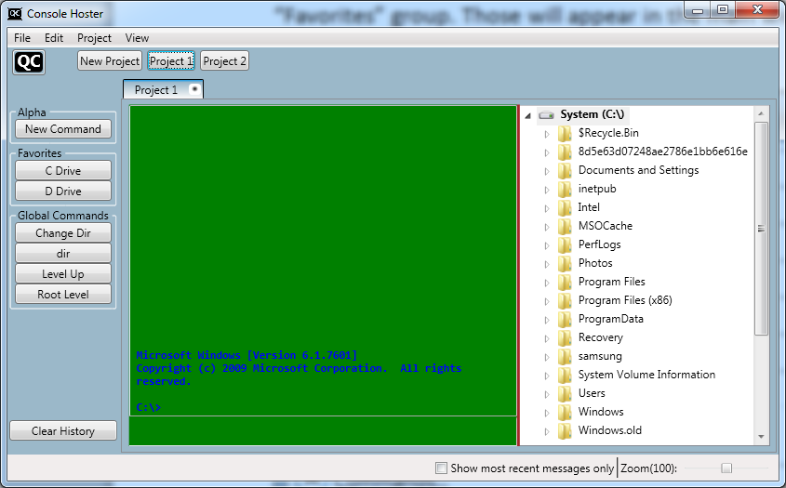

So on the left side list there are the commands, and for project 1 you see some are defined. So there is the Favorites group in which you see the C Drive and D Drive commands. The click on the D Drive command will bring the window to the following state:

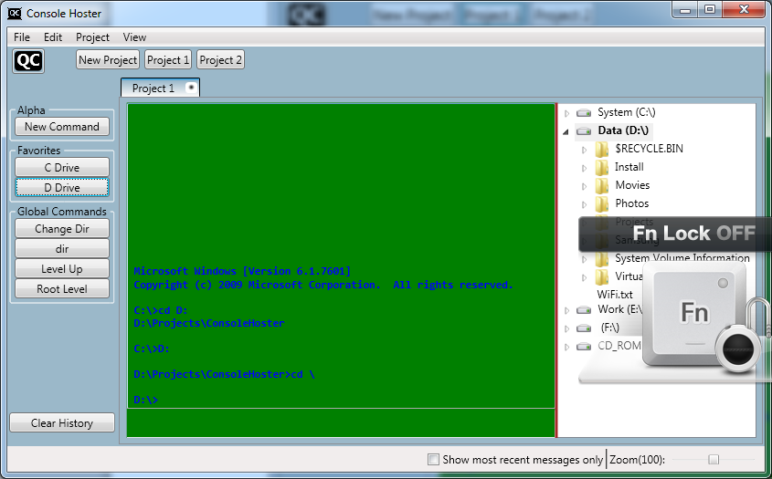

### Explorer tree

Each project window has its own explorer tree opened on the right hand side from the window. If the user navigates to Folder A for Project 1 and then switches to Project 2, he will still be in Folder A, when he will come back to Project 1, so the state is persistent.

The explorer tree has some well-integrated functionality. To find the capabilities of it just right click on an item in the tree and the following console window will appear:

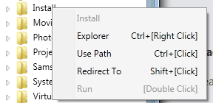

In the context menu the header item is always disabled and shows the explorer item name, which for the context menu has opened. So in the above example it is opened for Install folder. Next in the menu the following commands are available:

Explorer Opens Windows Explorer in the folder, where the item is

Use Path Pastes the path of the selected item to the command area to be used within a command

Redirect To Navigates to the selected folder in the console window.

Run This command is available for files only and it tries to execute the file from within the console window. So for example Double-Clicking a txt file in the explorer tree will open that file in the default text editor in windows.

As you can see there are hotkeys defined for those commands as well.

### Search in Output

There is search functionality in the project output window, which is available to Find text within the output from the project. Ctrl+F brings up that window. The user specifies the text and then clicks Next, and goes over each search result.